Justin Robinson and Katherine Damiano

**Astrophotometry with Meade ETX 125 and The SkyX**

**Setup and Operation Manual**

This manual has been designed for the undergraduate student who is taking, or has taken, Introductory Astronomy and/or Physics, or as a quick-start guide for the novice astrophotographer working with this configuration.

**Section 1: Equipment**

1.1 Equipment list

1.2 Recommended software

1.3 Proper care, handling, and storage of equipment

**Section 2: Setup**

2.1 Tripod

2.2 Mounting telescope on tripod

2.3 Connecting the remote

2.4 Eyepiece attachment

2.5 Viewfinder calibration and focusing

2.6 Polar alignment

2.7 Camera attachment: Orion Starshoot

2.8 Camera attachment: Canon EOS Rebel

**Section 3: Slewing to a Target**

3.1 Paddle Go-To

3.2 Viewing target through viewfinder/lens

3.3 Field of view adjustments

**Section 4: Taking Pictures**

4.1 DSLR

4.2 DSLR long exposures

**Section 1: Equipment**

1.1 Equipment List:

1) 884 Tripod for ETX90 and ETX 125 (Fig. 1)

2) Equatorial Mount (Fig. 1)

3) Meade ETX 125 Observer (Fig. 1)

4) Meade Controller (Fig. 3 & 13)

5) AA Batteries (Fig. 3)

6) Meade Super Plössl 26mm Multi-Coated Lens (Fig. 2)

7) TeleVue Zoom 8mm-24mm Lens (Fig.2)

8) Celestron T-Ring #93419 Canon EOS (Fig. 4)

9) Meade 07363 #64 T-Adapter for ETX 90-125 (Fig. 4)

Figure 2

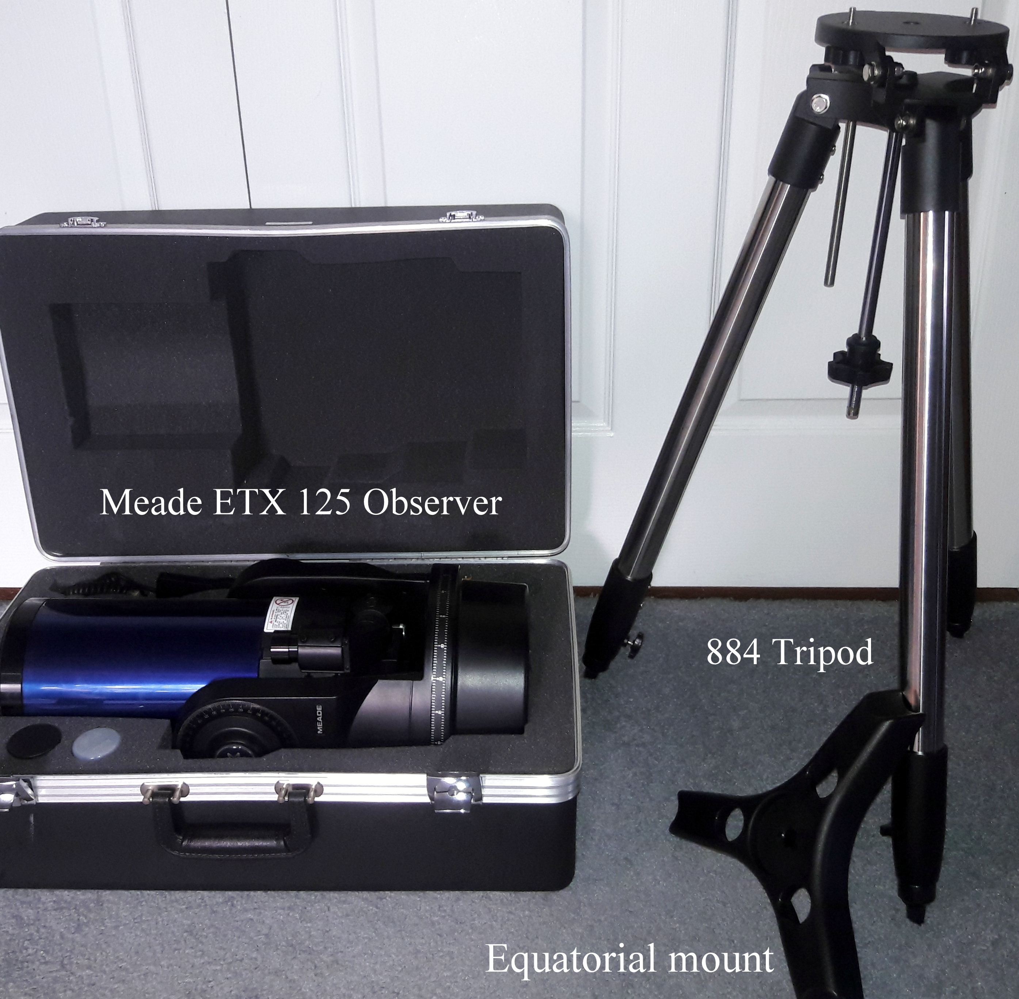

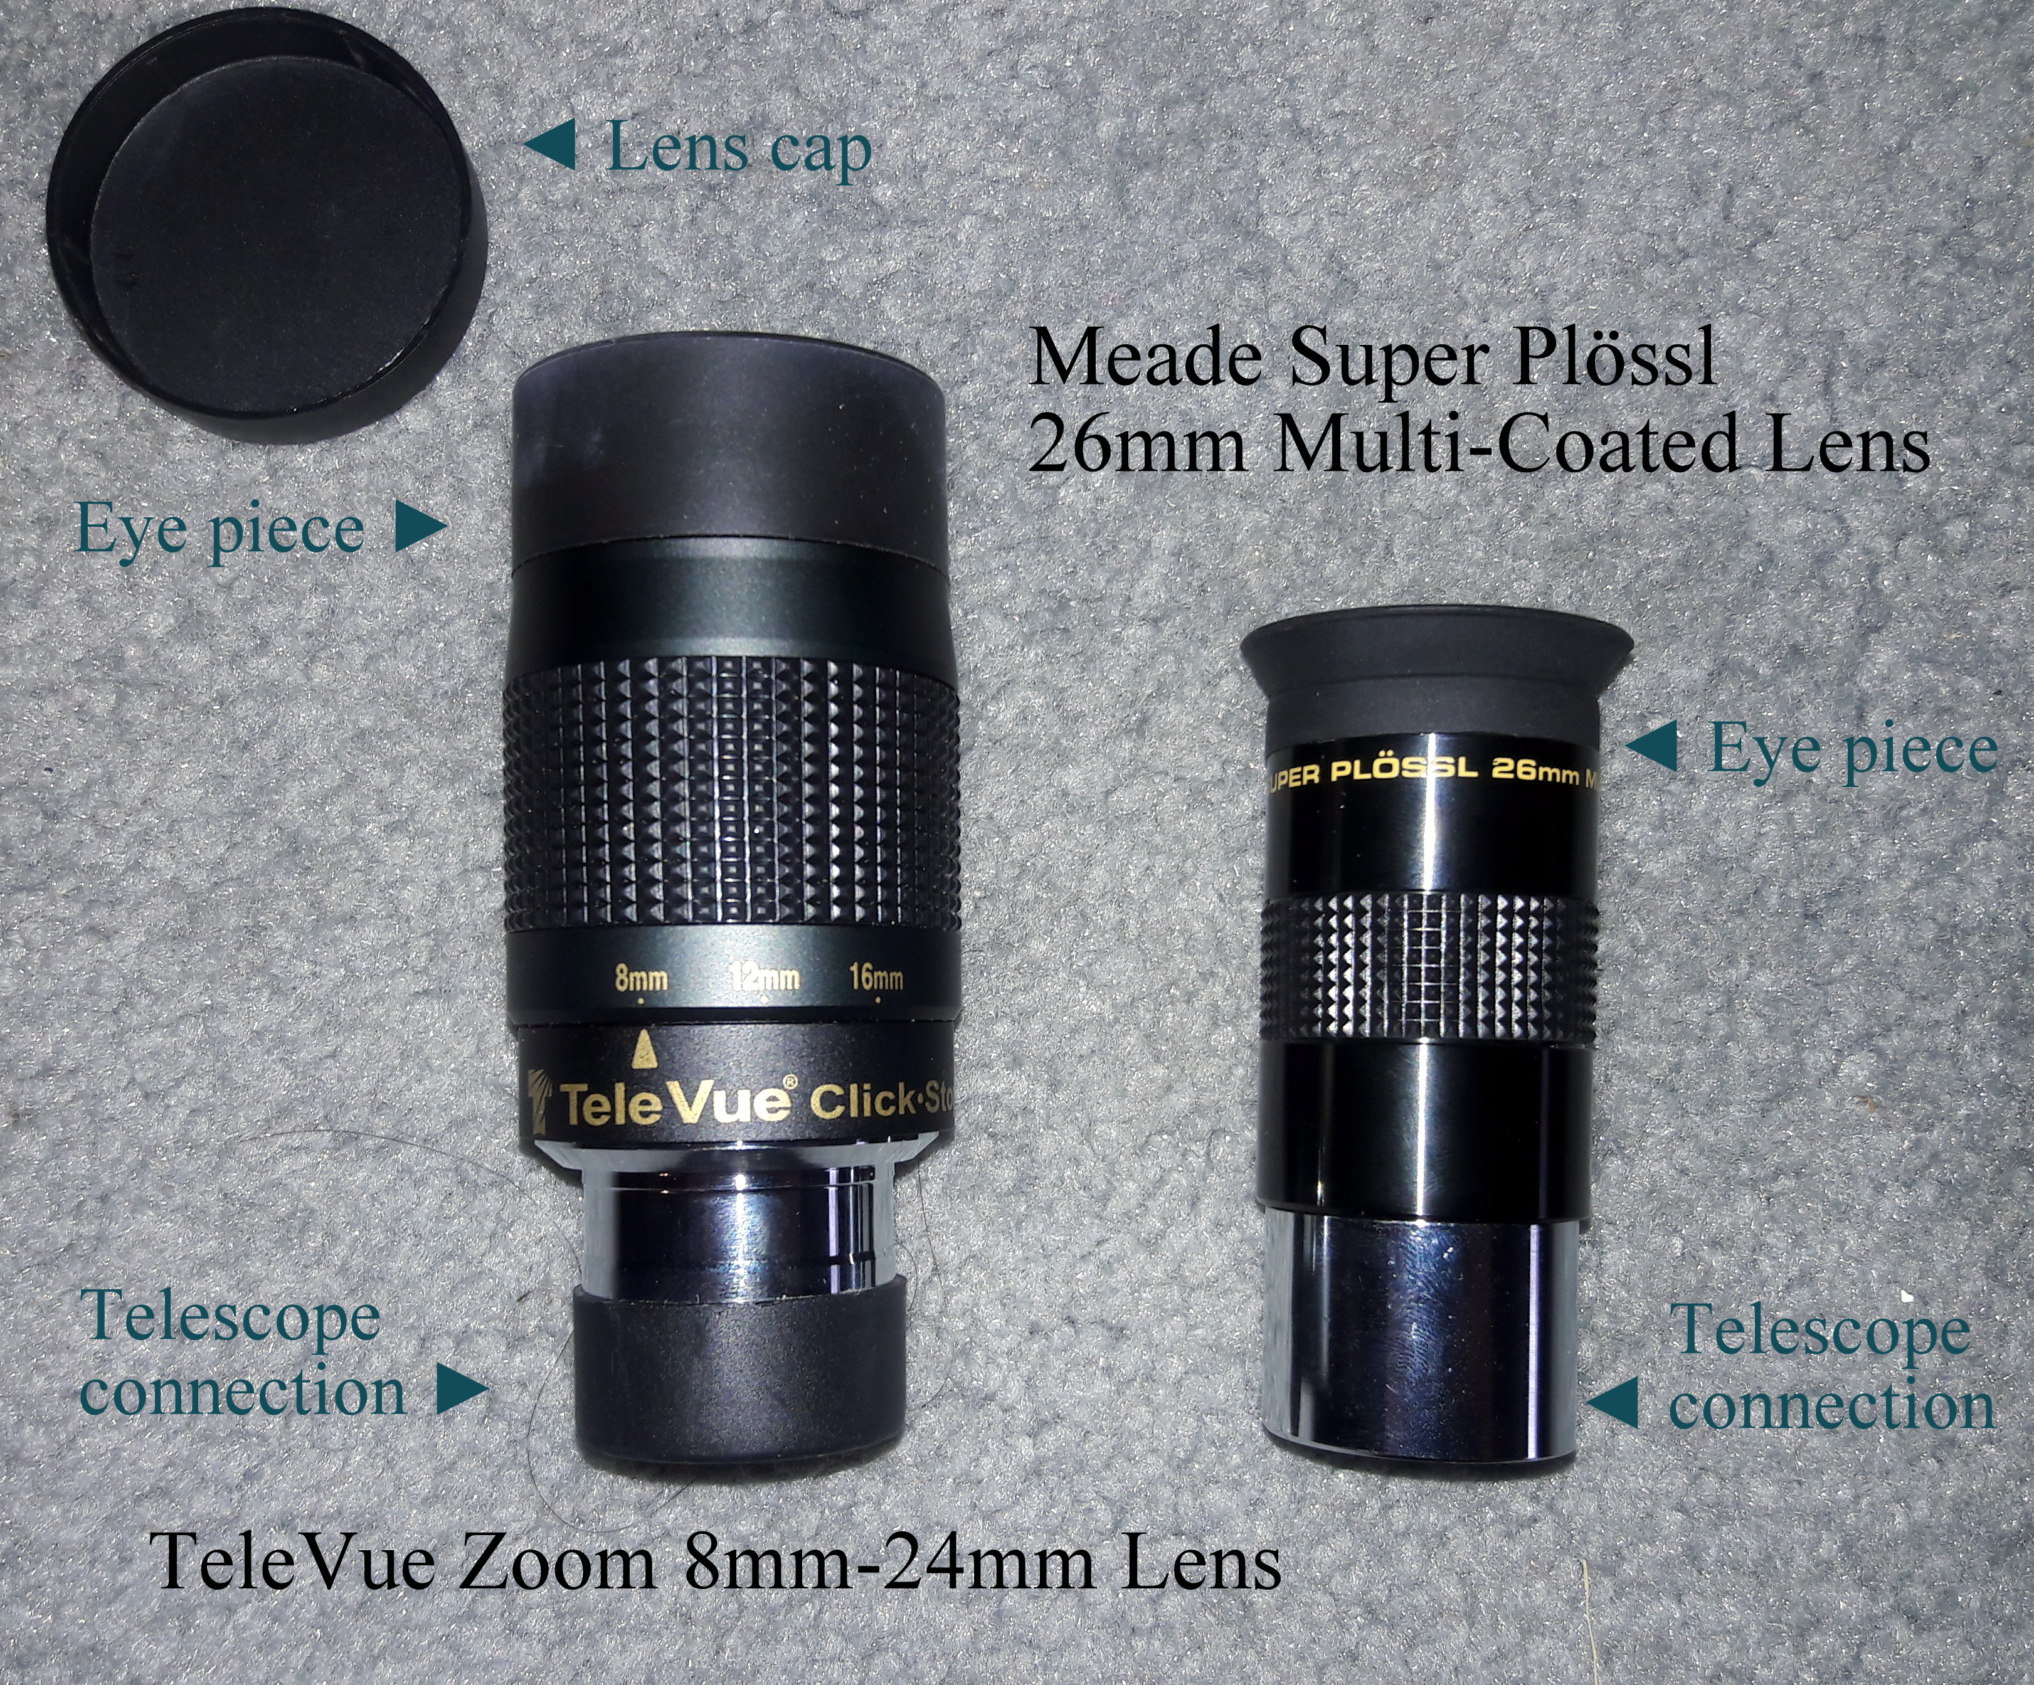

Figure 1

Figure 3

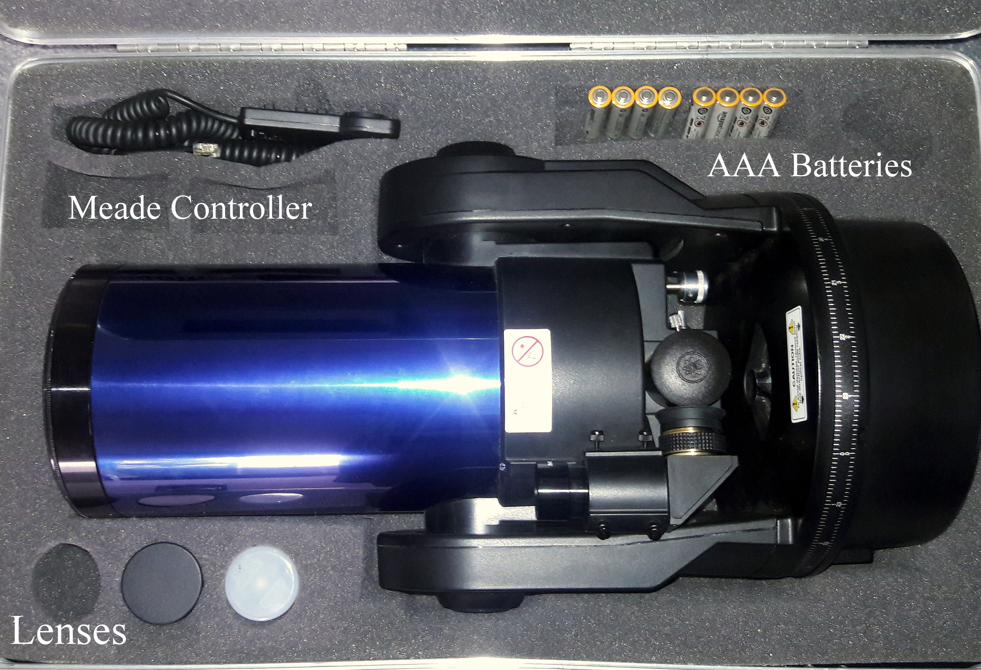

1.2 Recommended Software

The only recommended software is SkySafari from the Apple App Store. This app contains a very large selection of celestial objects in addition to all of the constellations. Viewing options vary between fixing the screen on an object of interest, or turning off the “Compass” option allowing free range of motion of the device, allowing the app to mirror objects in the sky according to where you point your device. The app also allows for night-viewing, which switches all light to red, allowing for easy dark-adaption for your eyes.

1.3 Proper care, handling, and storage of equipment

The carrying case that comes with the ETX 125 contains areas for each accessory of the telescope, including the telescope itself. When done observing, use the controller to place the telescope back in parking position, which is straight up or 90º with respect to the ground. Place the telescope in its proper shaped place in the center of the case.

Each lens has a place as well. Be careful never to touch the lens, always holding the side when in use and when storing. Place lenses in their plastic containers and place containers in their designated place in the case with the lens facing outward.

Place the controller in its designated place in the top left corner of the case.

The tripod comes equipped with a proper bag. Place the scope in the bag and the equatorial mount in the separate compartment at the bottom of the bag.

**Section 2: Setup**

2.1 Tripod

The tripod contains adjustment screws on the end of each leg (Fig. 5). Unscrew to release extensions of each leg until the desired height is achieved, then tighten screws again. Take out the equatorial mount from the bottom of the bag. Unscrew the wheel beneath the coil underneath the center of the tripod (Fig. 6). Place the equatorial mount on the rod, placing each curved side against each leg of the tripod. Screw back in the coil and wheel until tight. Your tripod is now equatorially balanced and will not shift leg positions (Fig. 7).

Figure 7

Figure 6

Figure 5

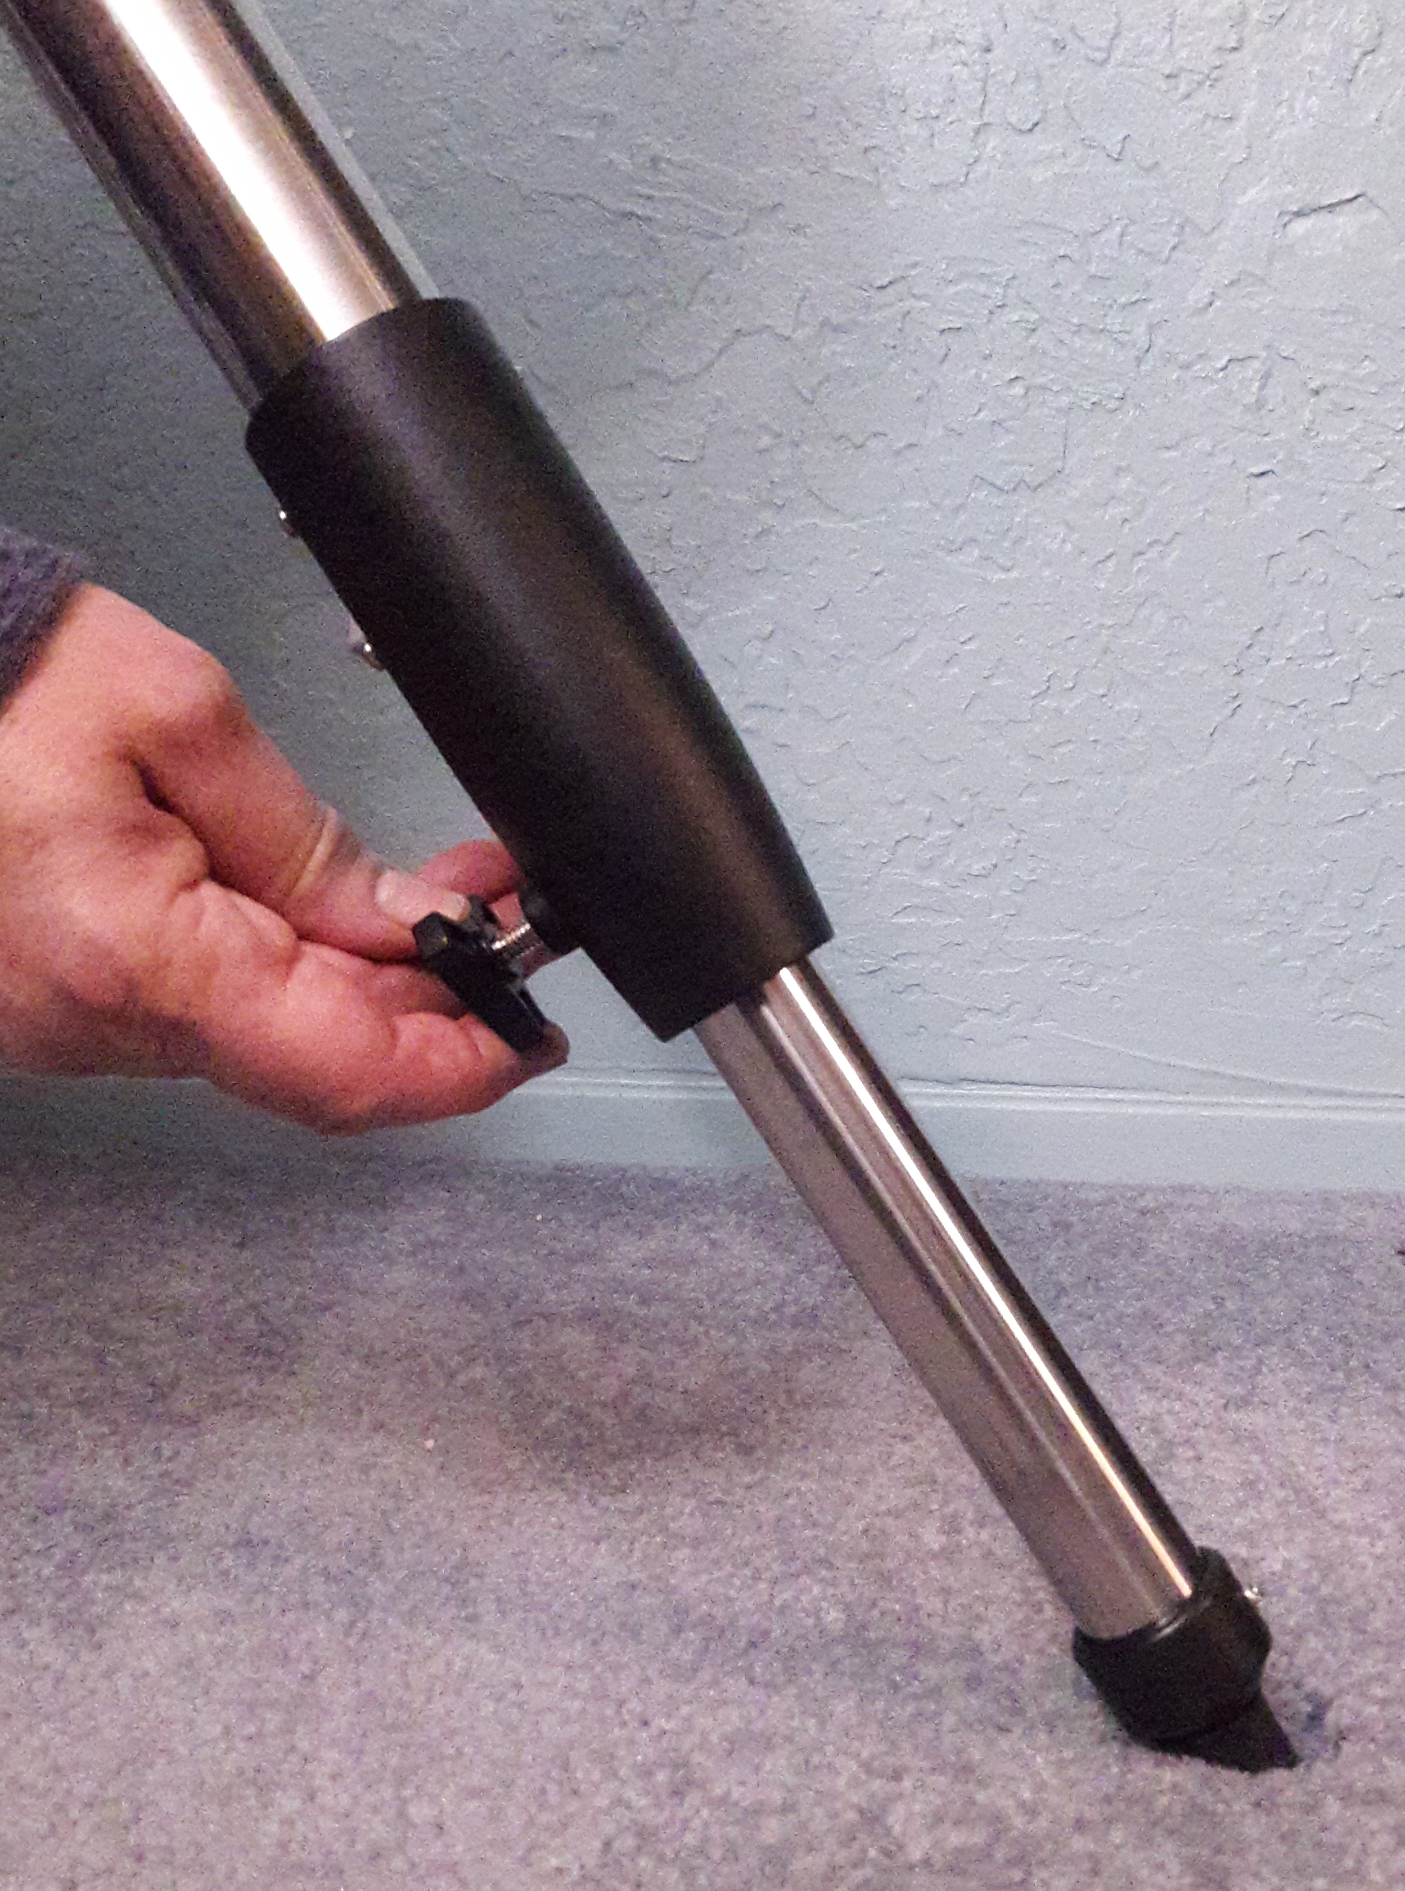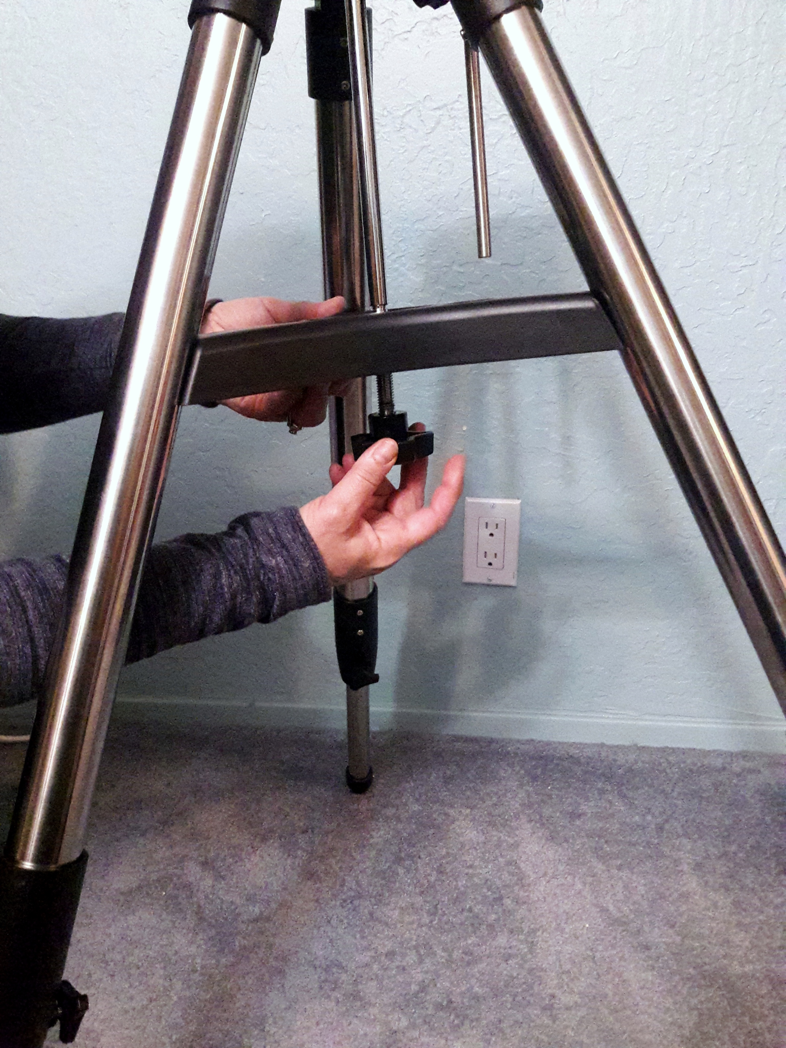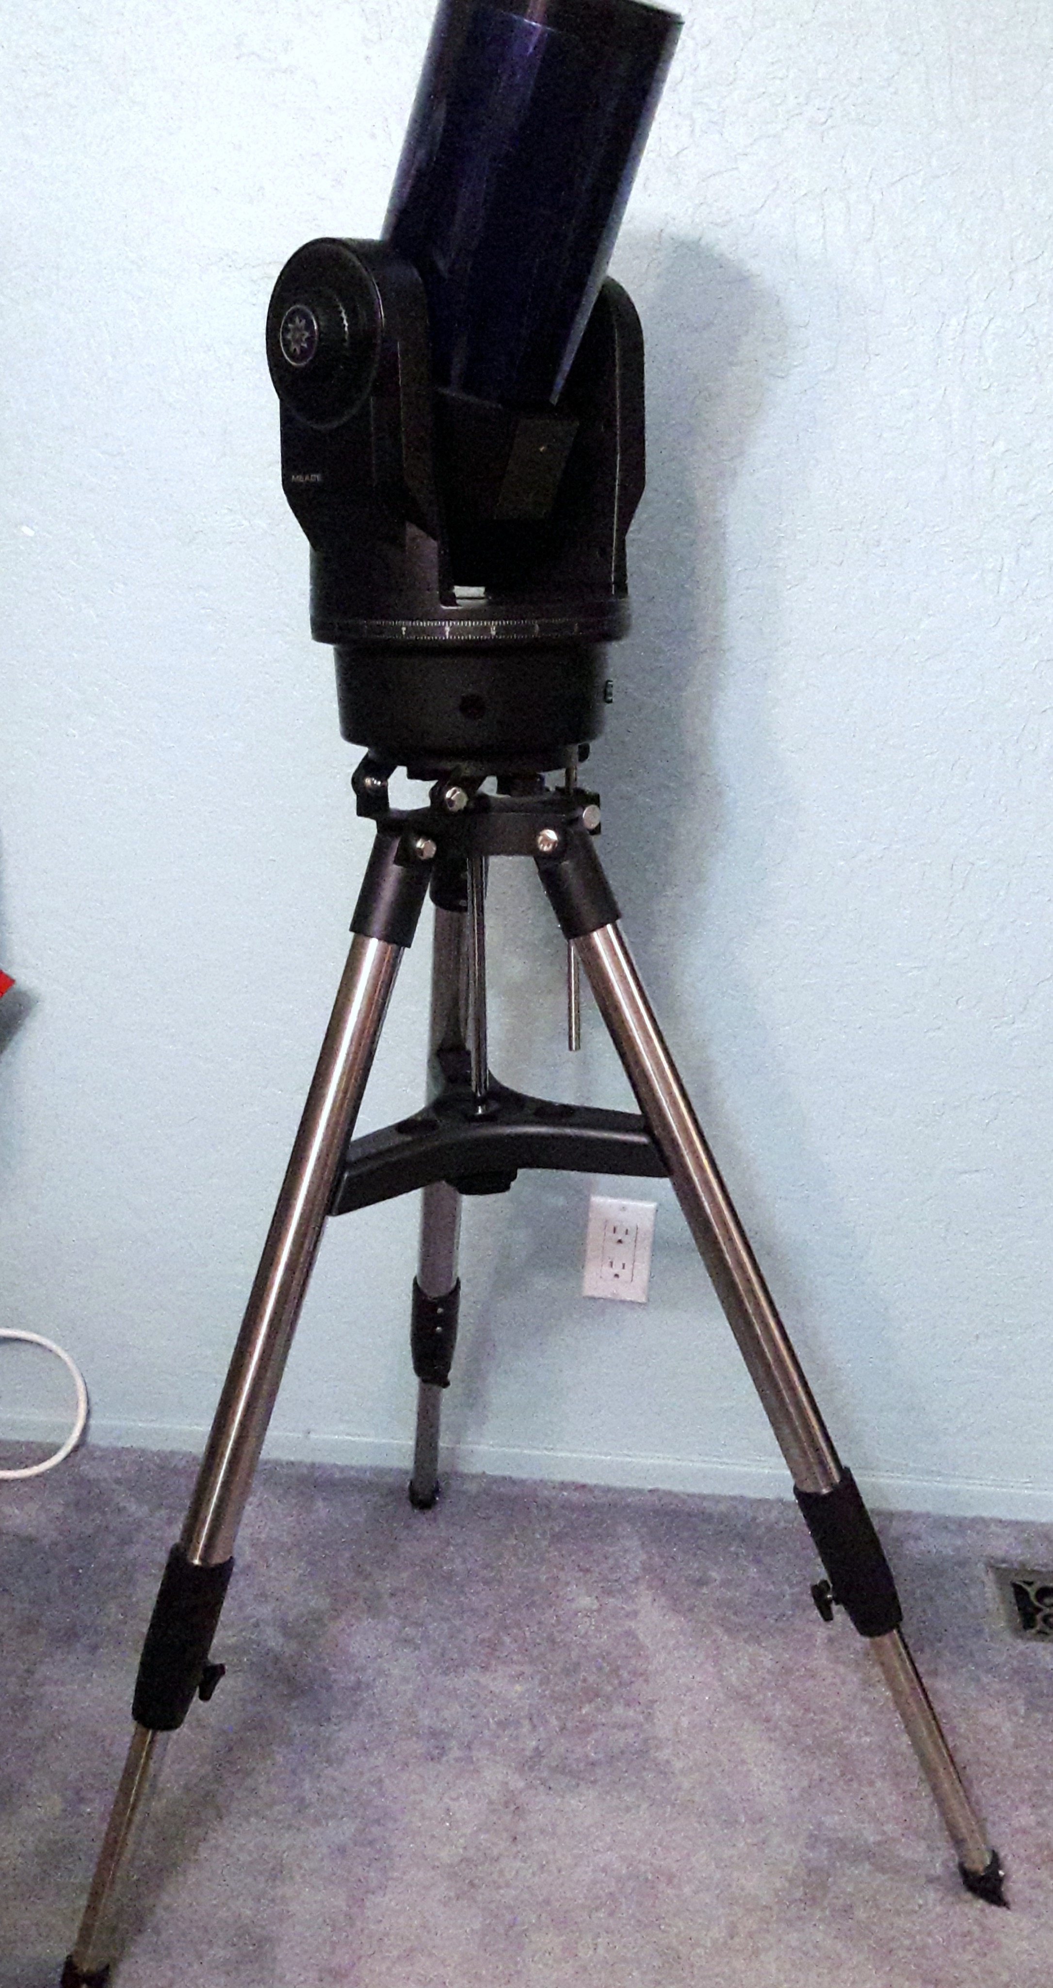

2.2 Mounting telescope on tripod

The tripod contains two screws sitting beneath the top surface which correspond to two screw holes underneath the telescope. It might be helpful to mark with tape the positions of the screws and holes. Place the telescope on top of the tripod and screw in the screws until tightened (Fig. 8).

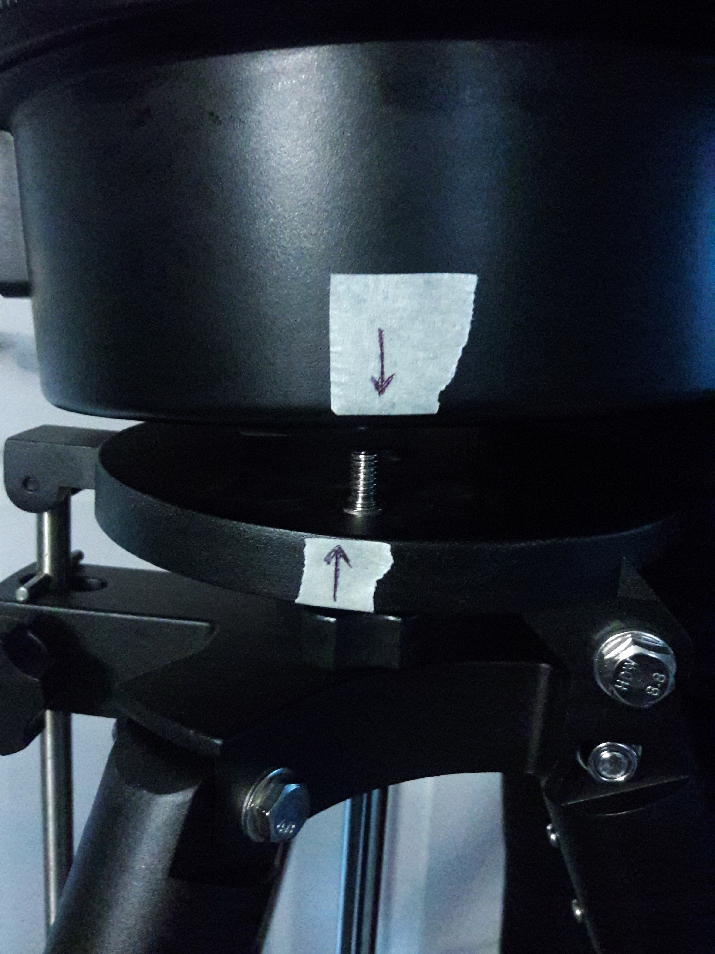

Figure 8

2.3 Connecting the Remote

Connect the remote to the appropriate input on the base of the telescope (Fig. 12). The directional buttons will now control the telescope’s movement. The “Speed” button adjusts how fast the telescope slews (adjusts its position). The top light is the fastest and the bottom is the slowest (Fig 13).

Figure 13

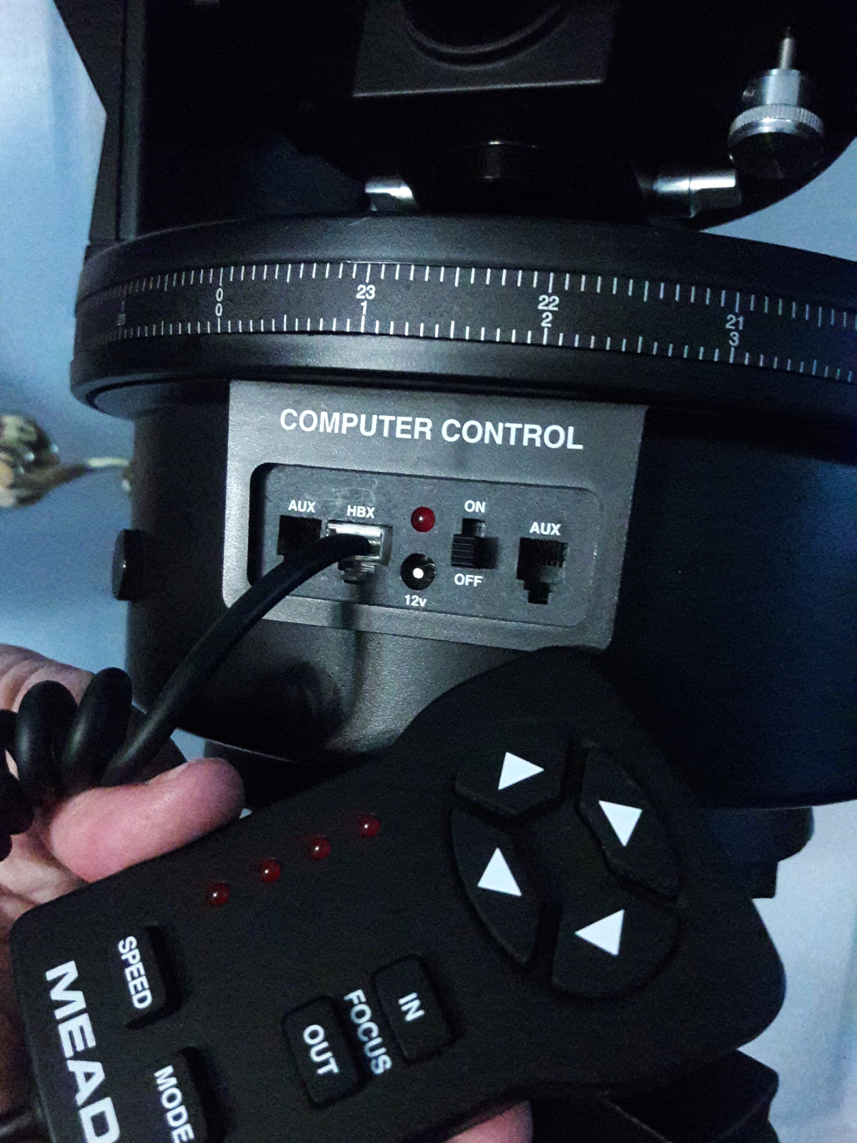

Figure 12

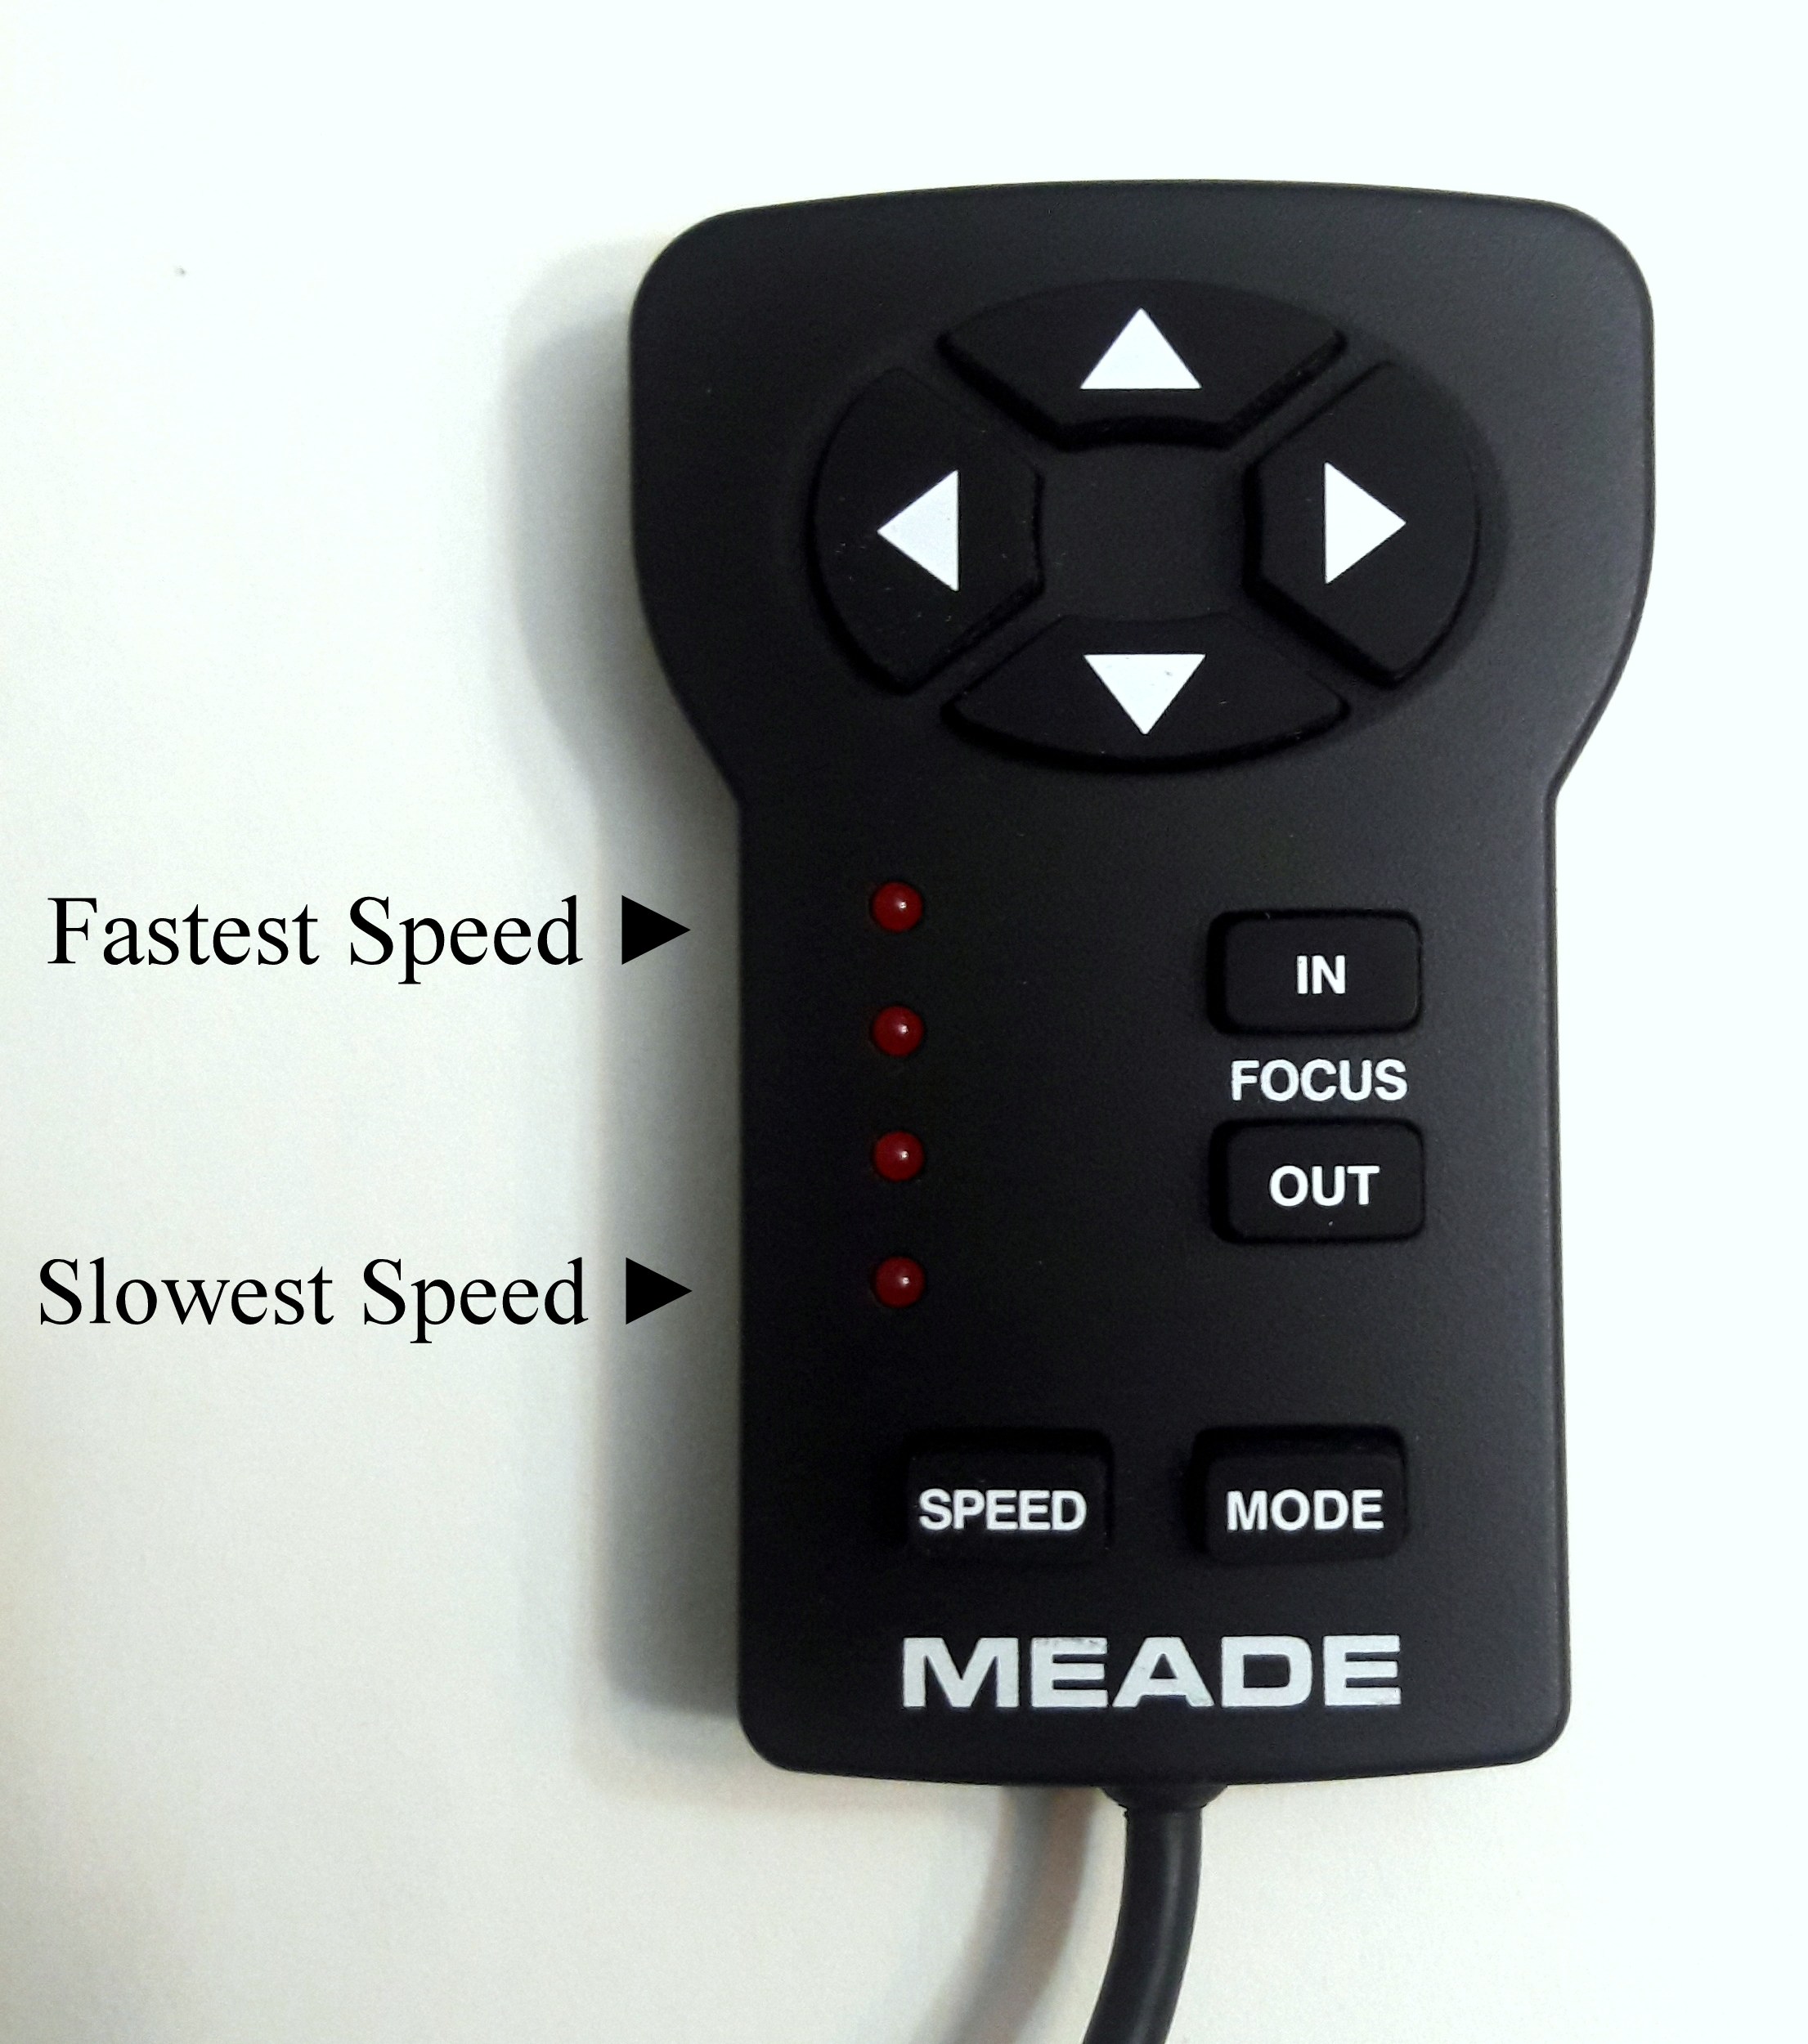

2.4 Eyepiece attachment

For ease of finding an object before getting a closer view, you want to use a lens with a wide field of view and less zoom in order to see more of the sky. Remove the cap to the right of the viewfinder (Fig. 14), place the Meade Super Plössl 26mm Multi-Coated Lens (Fig. 3) in, and tighten the screw to the right of the lens until tight (Fig. 15).

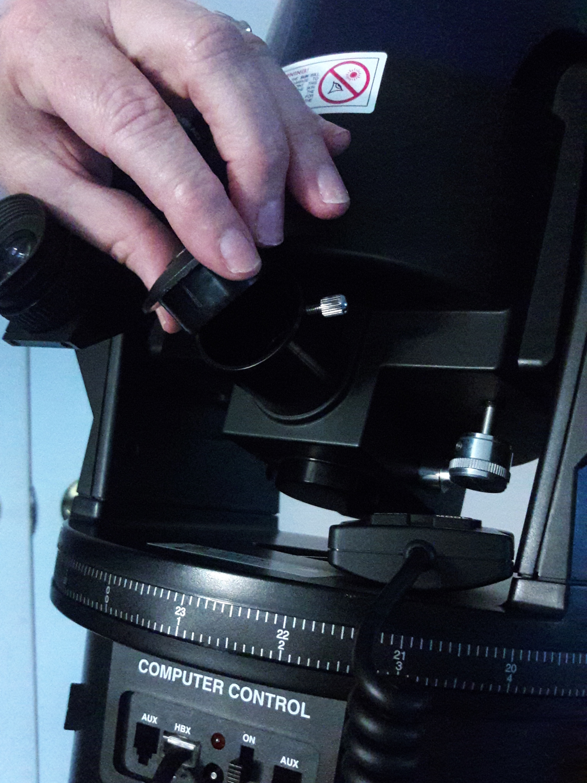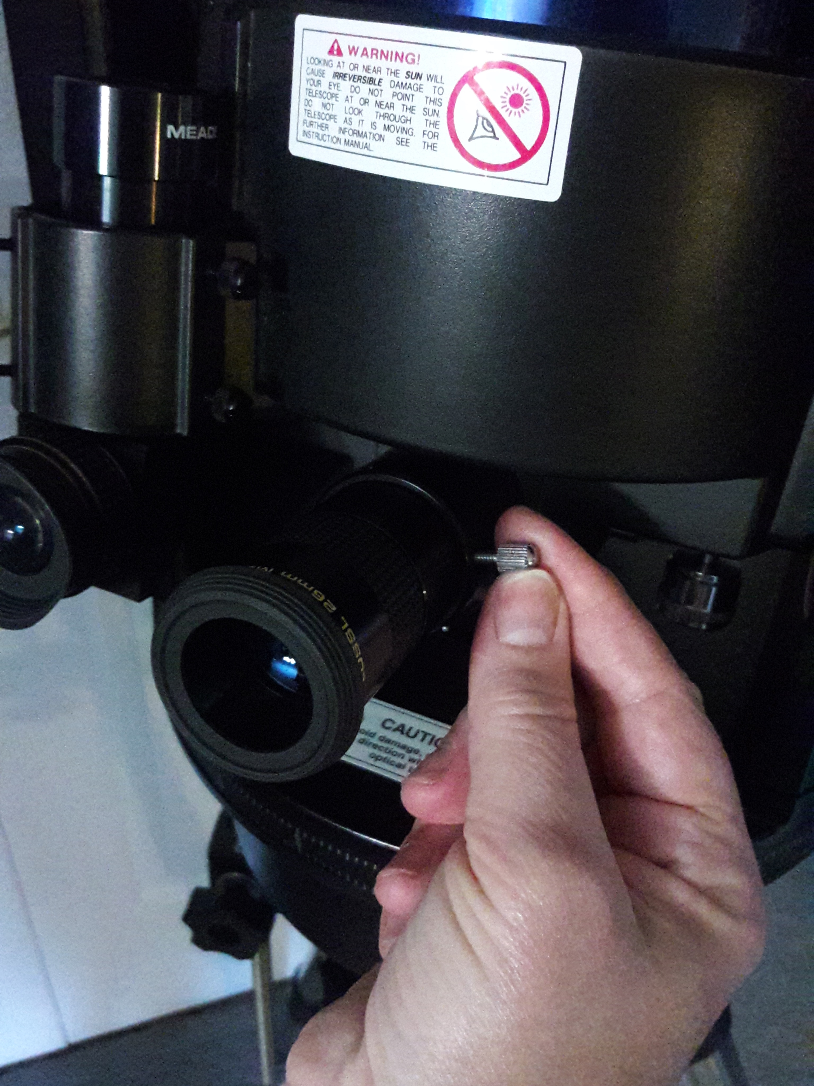

Figure 15

Figure 14

2.5 Viewfinder calibration and focusing

In order for the viewfinder to be helpful, i.e. in order for it to be aimed in the same direction as your scope, the object must always be centered in the viewfinder as well as the scope. To do this, slew the telescope to a nearby object. Once found through the main lens, put the object into focus. Screwing the focuser knob counterclockwise will focus on objects close by (Fig. 16). Once in focus, slew the scope until the object is at the center of the field of view. Now view the object through the viewfinder. If not in the center, adjust the screws on the outside of the holder of the viewfinder two at a time; meaning, grab two screws on two sides of the holder on the same row, and screw one in clockwise as you simultaneously unscrew the other counterclockwise (Fig. 17). Continue to do this with different pairs of screws on the same row until the object reaches the center of the viewfinder’s field of view. Your viewfinder is now calibrated and ready for observing.

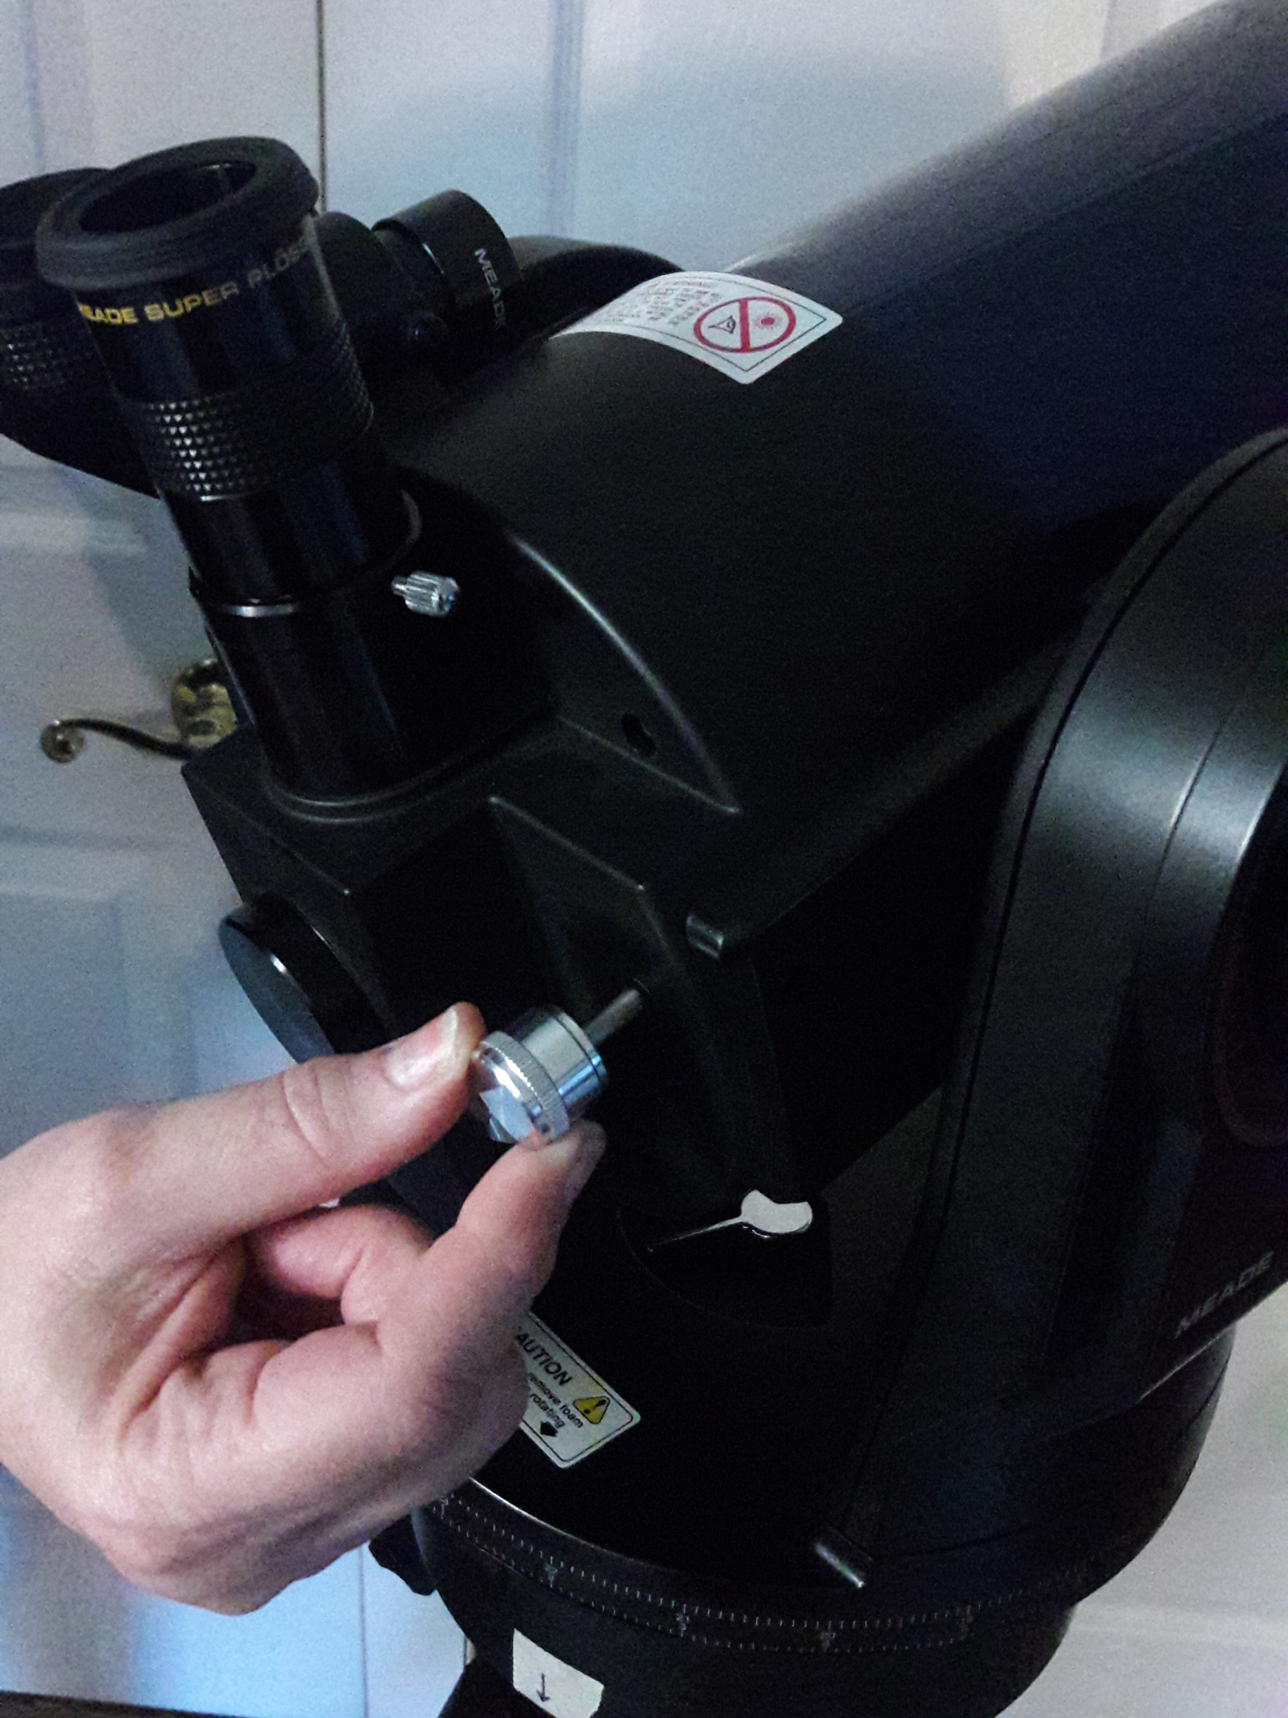

Figure 16

Figure 17

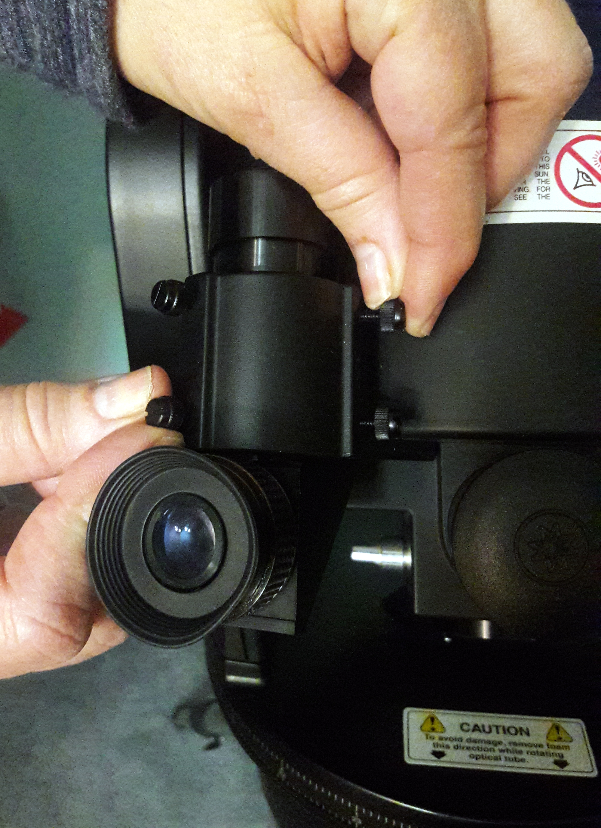

2.6 Polar alignment

For astrophotography, it is best to polar align your scope in order to avoid the object’s image moving on the CCD detector of your camera. This is because when aligned, the scope will move in concordance with the movements of the stars in the sky, preventing an object’s position on the CCD from moving over time. To do this, locate Polaris, or the North Star, in the sky. The easiest way to spot it is identifying the Big Dipper and following along the line outlined by the farthest edge, as shown in Fig. 11. Next, pick up the entire assembly of tripod and scope and aim the north-facing tripod leg towards Polaris. The north-facing leg is the leg opposite the control panel of the scope when mounted. After, locate Polaris in your viewfinder by moving the entire assembly and adjusting the latitude control bar as shown in Fig. 9. It is important to keep your scope perpendicular to the base of the tripod during this procedure. To get precise latitude, look up the latitude of your observing location which can be found on page 55 of the ETX manual. Adjust the latitude bar until your latitude is just visible above the flat surface of the tripod mount. Once you have located Polaris in your viewfinder, be sure it is visible in the center of the field of view of your lens. Before locating another star, be sure that the declination setting circle (shown in Fig. 10 90 degrees clockwise from the lens) is set to 0 directly above the molded triangle pointer.

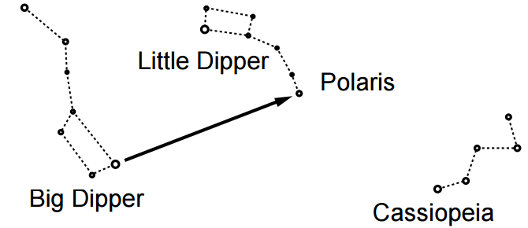

Figure 11

The next step is to look up the Right Ascension and Declination coordinates of a bright star in the sky during the time of year in which you are observing, which can be found online. Once you have found the RA and DEC coordinates of a bright star, manually move the right ascension of your scope by unlocking the lever directly beneath your scope. Center the star in the scope’s field of view by manually moving the RA of the scope, locking the lever, an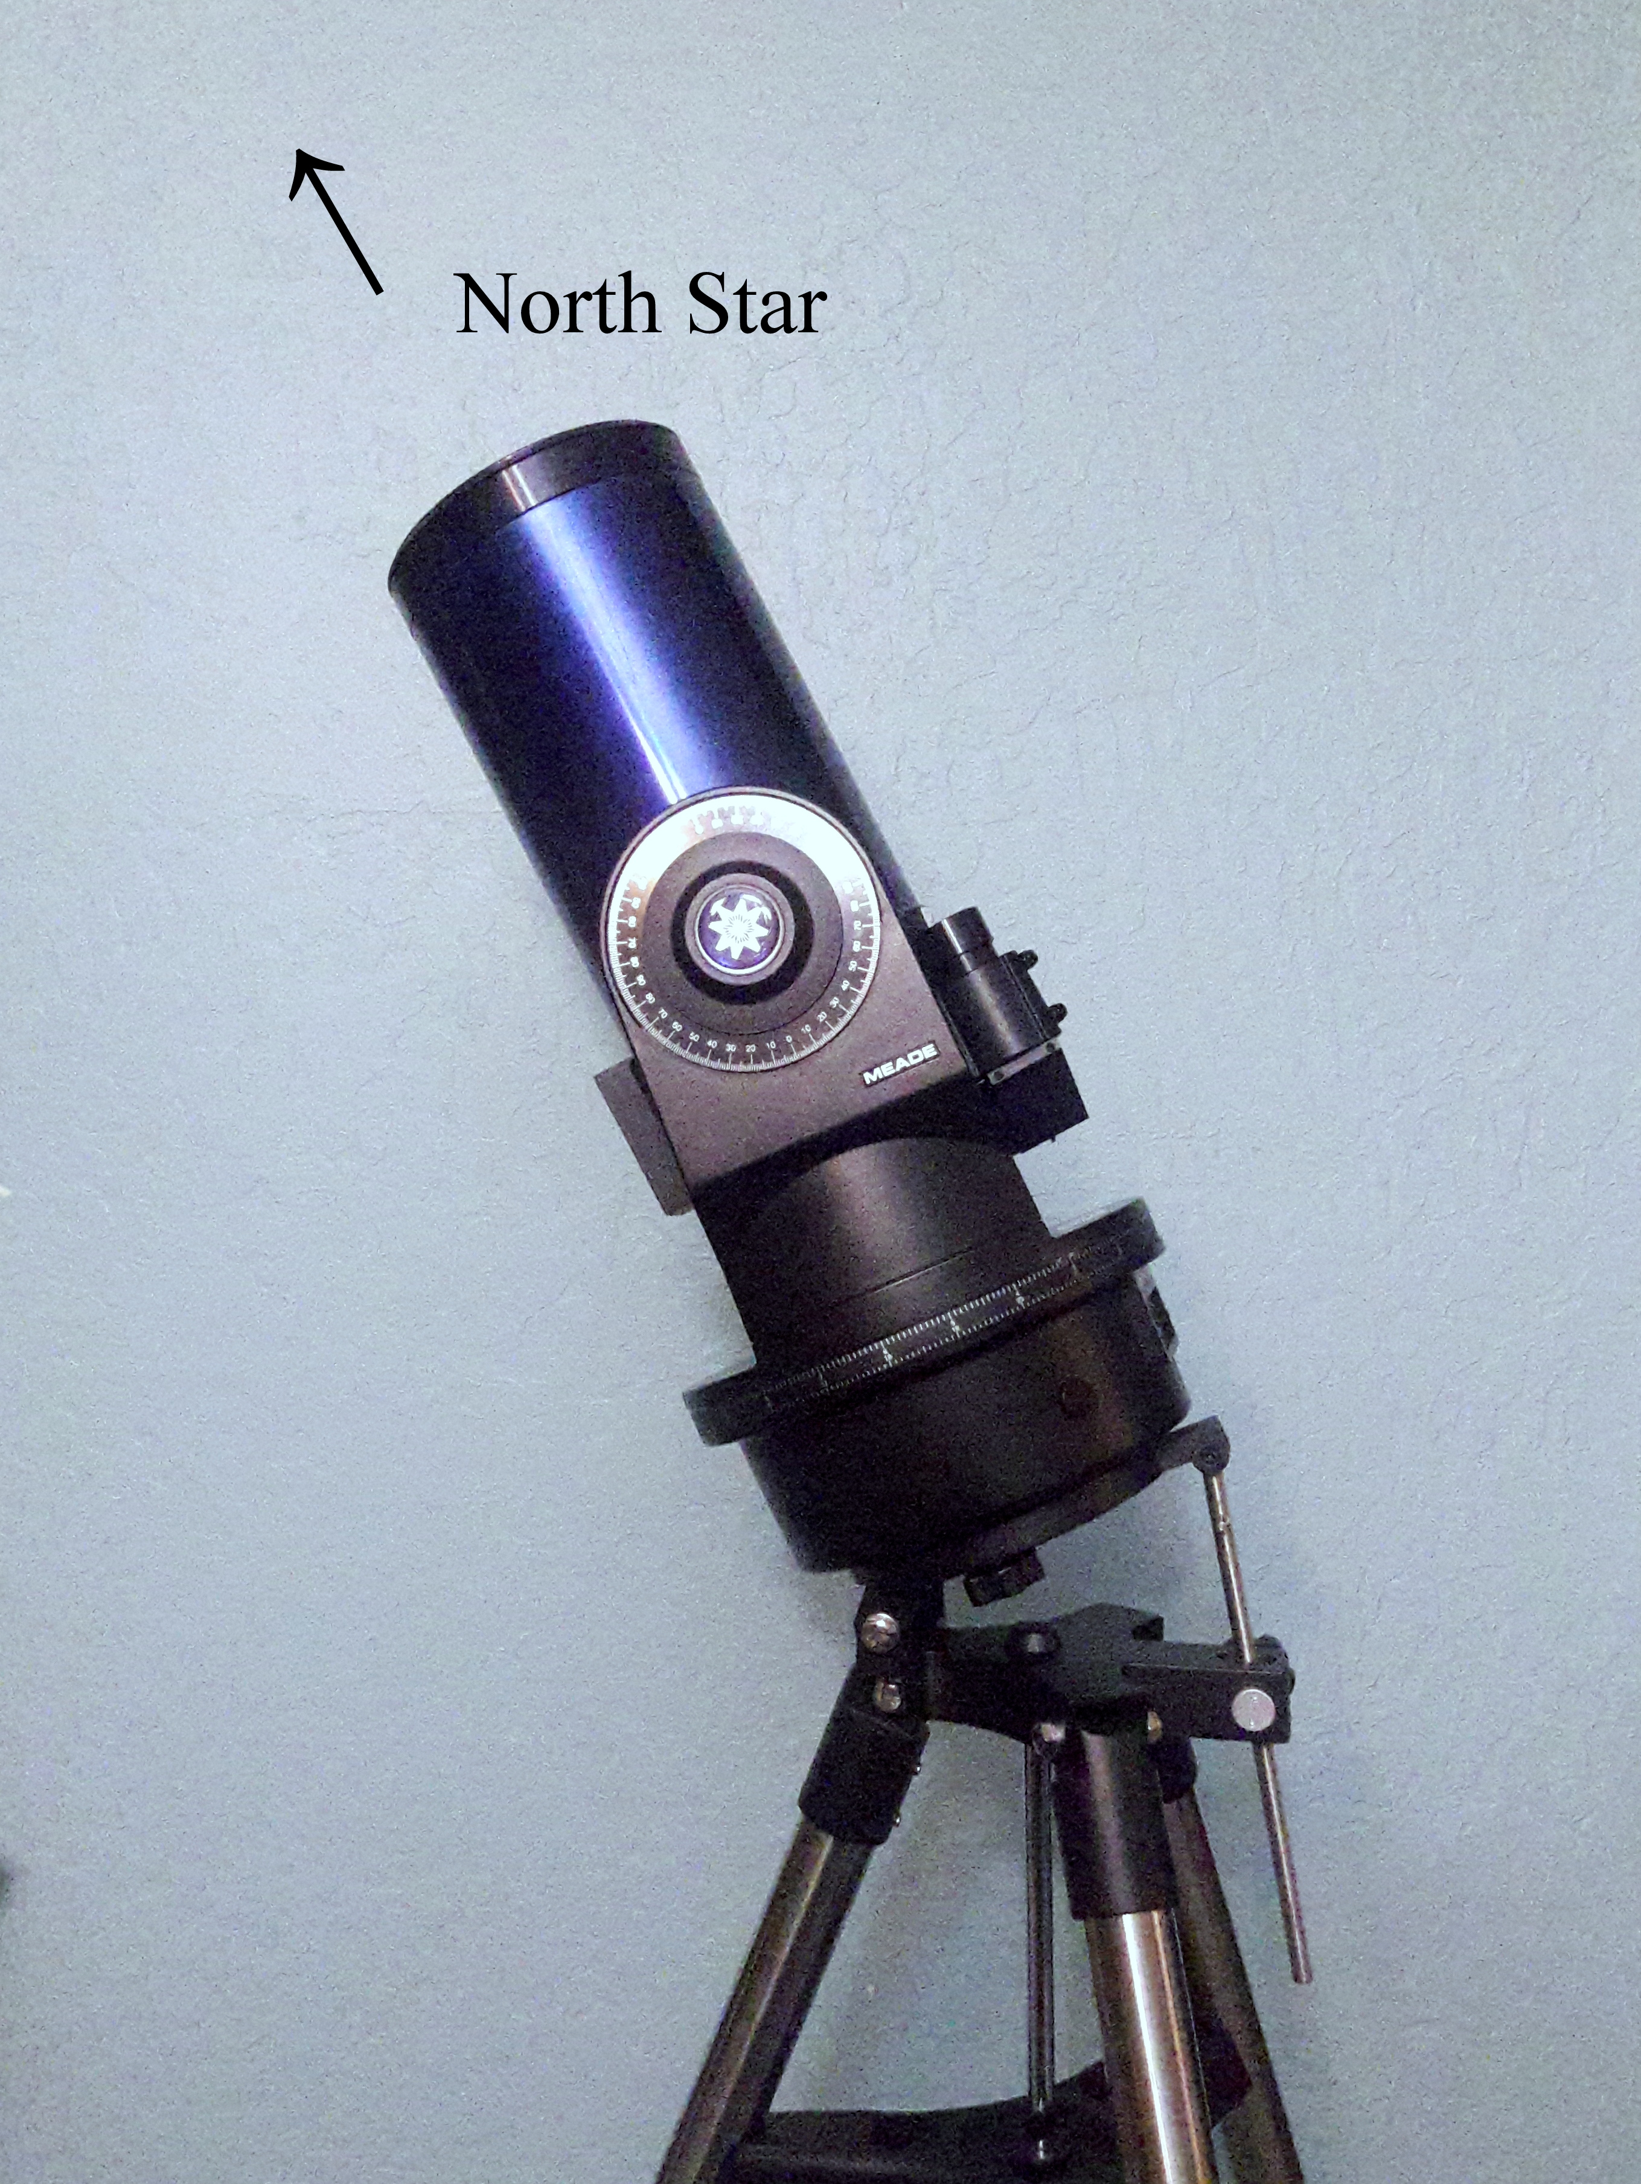d manually moving the DEC of the scope by unlocking the DEC lock 180 degrees opposite the DEC setting circle, and locking the DEC lock again. Next, adjust the RA setting circle, located directly above the computer control panel, to read the RA of the star at the RA pointer, or the molded triangle pointer. The setting circles must not be moved after this during observing. Your scope is now polar aligned and will read the correct RA and DEC coordinates on the setting circles.

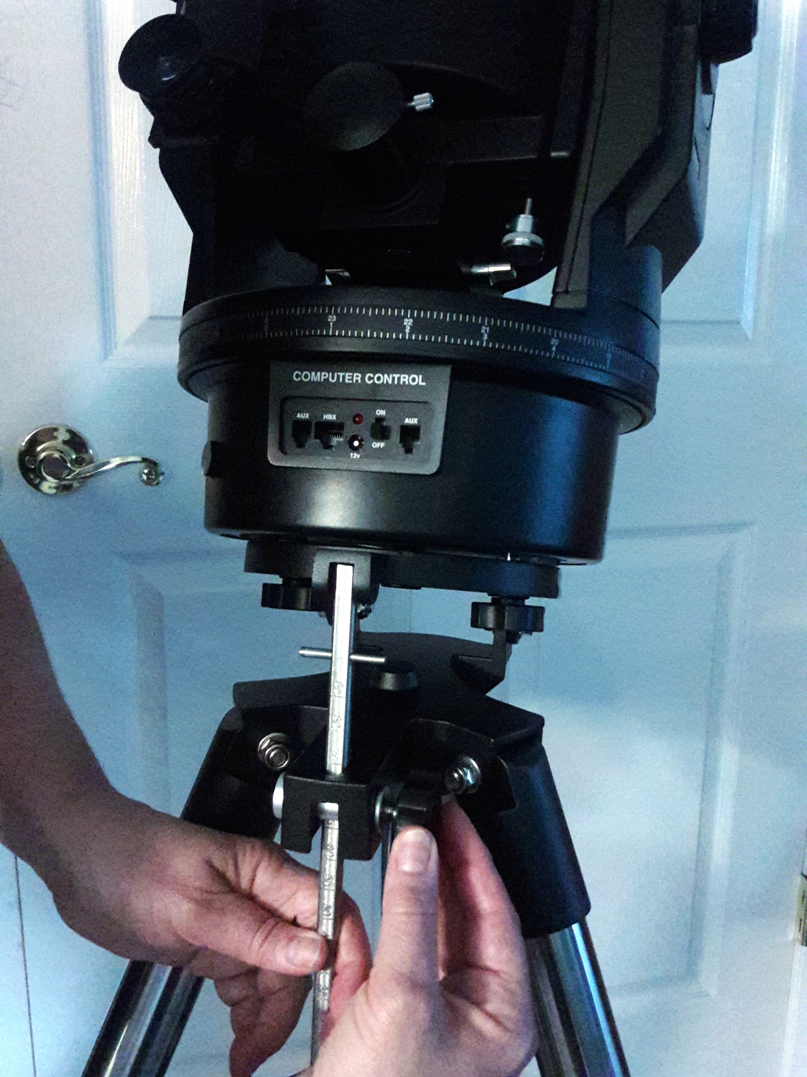

Figure 9

Figure 10

2.7 Camera attachment: Orion Starshoot

Remove the orange lens cap from the Orion Starshoot Camera. Then screw on the Meade 07363 #64 T-Adapter for ETX 90-125 (Fig. 4) to the lens. Then connect the T-adapter to the telescope photo port. Screw in until tightly secured. Pug in camera to USB port on your computer or laptop, and to a power supply.

2.8 Camera attachment: Canon EOS Rebel

Disconnect the lens from the EOS Rebel and replace it with the Celestron T-Ring (Fig. 4). Then, attach the Meade T-Adapter to the T-Ring on the Rebel (Fig.4). Lastly, place the T-Adapter+T-Ring+Camera assembly against the photo port on the scope directly below the eyepiece holder. Screw the front of the T-Adapter to the photo port until tightly secured.

**Section 3: Slewing to a Target**

3.1 Paddle Go-To

Adjust the speed to the highest setting on the controller. Using SkySafari as a guide to the position of an object of interest, use the directional buttons to slew to the estimated location of the desired object. You can either eyeball the position of the telescope’s line of sight, or hold your device in front of the telescope and slew until the object’s position in SkySafari corresponds to the middle of your scope.

3.2 Viewing target through viewfinder/lens

Decrease the speed on the controller to allow for easier target finding. Use the viewfinder, assuring to focus it so celestial objects are now in focus, to look for your object. Tap on the directional buttons to sweep the sky until object is found. Once in the viewfinder’s field of view, view the target through the lens and adjust the focus until the object’s image is crisp.

3.3 Field of view adjustments

Now that you have your object found and focused, and if a closer look is desired, switch the lens from the Meade Super Plössl 26mm Multi-Coated lens to the TeleVue Zoom 8mm-24mm lens, assuring you place the TeleVue at the 24mm setting before placing in the scope. At 24mm, the object’s image should be near identical to before. As you rotate the TeleVue lens, it will zoom in further, allowing for adjustment of the focus in conjunction with zooming in. Continue to adjust the focus until 8mm is reached.

**Section 4: Taking Pictures**

4.1 DSLR

Once you have found and focused on a desired object, there are a number of ways to take a photo. For a single image, after the object has been found in the lens, turn down the flip-mirror control knob to allow light into the censor of the camera. Modification of the focus might be needed in order to bring the object into focus on the camera screen. For a single image, it is easiest to set a timer delay to allow for any shaking to cease before the camera captures an image. Then simply hit the shutter button on your camera to take a picture of the image.

4.2 DSLR long exposures

For a long exposure, adjust the wheel right before the shutter button to change the exposure times. For this scope, 2-5 seconds is the recommended exposure time band. Once the shutter button is hit, the camera will collect light for however long the set exposure time window is.